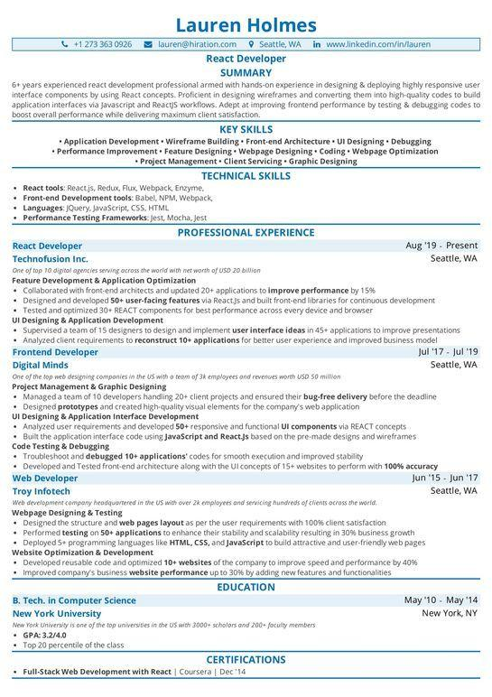
Lauren Holmes
+1.273 363 0926
lauren@hiration.com Seattle, WA in www.linkedin.com/in/lauren React Developer SUMMARY
6+ years experienced react development professional armed with hands-on experience in designing & deploying highly responsive user interface components by using React concepts. Proficient in designing wireframes and converting them into high-quality codes to build application interfaces via Javascript and Reactjs workflows. Adept at improving frontend performance by testing & debugging codes to boost overall performance while delivering maximum client satisfaction.
KEY SKILLS
• Application Development Wireframe Building Front-end Architecture UI Designing. Debugging •Performance Improvement. Feature Designing Webpage Designing Coding Webpage Optimization • Project Management Client Servicing⚫ Graphic Designing
TECHNICAL SKILLS
• React tools: React.js, Redux, Flux, Webpack, Enzyme. Front-end Development tools: Babel, NPM, Webpack, Languages: JQuery, JavaScript, CSS, HTML
• Performance Testing Frameworks: Jest, Mocha, Jest
React Developer
Technofusion Inc.
PROFESSIONAL EXPERIENCE
One of top 10 digital agencies serving across the world with net worth of USD 20 billion
Feature Development & Application Optimization
• Collaborated with front-end architects and updated 20+ applications to improve performance by 15%
Aug '19 Present Seattle, WA
• Designed and developed 50+ user-facing features via Reactjs and built front-end libraries for continuous development
• Tested and optimized 30+ REACT components for best performance across every device and browser
UI Designing & Application Development
• Supervised a team of 15 designers to design and implement user interface ideas in 45+ applications to improve presentations
• Analyzed client requirements to reconstruct 10+ applications for better user experience and improved business model Frontend Developer
Digital Minds
One of the top web designing companies in the US with a team of 3k employees and revenues worth USD 50 million
Project Management & Graphic Designing
Jul '17 Jul '19 Seattle, WA
• Managed a team of 10 developers handling 20+ client projects and ensured their bug-free delivery before the deadline
• Designed prototypes and created high-quality visual elements for the company's web application
UI Designing & Application Interface Development
• Analyzed user requirements and developed 50+ responsive and functional UI components via REACT concepts
• Built the application interface code using JavaScript and React.js based on the pre-made designs and wireframes Code Testing & Debugging
• Troubleshoot and debugged 10+ applications' codes for smooth execution and improved stability
• Developed and Tested front-end architecture along with the Ul concepts of 15+ websites to perform with 100% accuracy Web Developer
Troy Infotech
Web development company headquartered in the US with over 2k employees and servicing hundreds of clients across the world. Webpage Designing & Testing
• Designed the structure and web pages layout as per the user requirements with 100% client satisfaction
• Performed testing on 50+ applications to enhance their stability and scalability resulting in 30% business growth
Jun '15 Jun '17 Seattle, WA
• Deployed 5 programming languages like HTML, CSS, and JavaScript to build attractive and user-friendly web pages Website Optimization & Development
• Developed reusable code and optimized 10+ websites of the company to improve speed and performance by 40%
• Improved company's business website performance up to 30% by adding new features and functionalities
B. Tech. in Computer Science
EDUCATION
New York University
New York University is one of the top universities in the US with 3000+ scholars and 200+ faculty members
• GPA: 3.2/4.0
Top 20 percentile of the class
CERTIFICATIONS
Full-Stack Web Development with React | Coursera | Dec '14
May '10 May '14
New York, NY

